DAD 220 Module One Lab Template

Overview
To complete this lab, go to your Codio virtual lab environment and start a new terminal session. Once there, perform the steps below to complete this activity. Manually enter any commands you are asked to write.

At the end of each step in the activity, replace the bracketed text with a screenshot, brief explanation, or both, as indicated. Size each screenshot and its explanation to fit about one-quarter of the page with the description written below the screenshot. Review the Template Screenshot Example linked in the guidelines and rubric for this assignment to see an example of how screenshots for your assignment should look.

Create a Database
- Create a new database and update the name to your last name; then connect to it. Type the following commands after the prompt mysql>:

  - CREATE DATABASE last_name_here;
    - For example, if your database is going to be named Jetson, then substitute "Jetson" for "last_name_here".
    - Press Enter.
  - SHOW DATABASES;
    - Press Enter.
    - You should see a listing of all of the databases (or schemas) in MySQL, including the one you just created.
  - USE last_name_here;
    - Press Enter.
    - Substitute the name of your database (for example, "Jetson") for "last_name_here". This SQL statement connects your MySQL session to the database you just created.
  - Capture a screenshot of the results of this action.

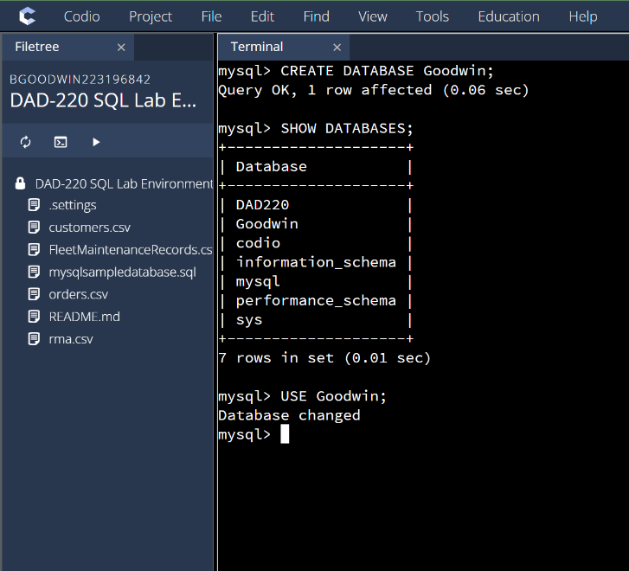

This screen shot shows me creating a database named Goodwin, showing what databases are available in the server and using the database with my own personal data.

- Create a table called tb2 and list out the tables in your database with one field by typing the following commands after the prompt mysql>:

  - CREATE TABLE tb2 (user_id VARCHAR( 50 ));
    - Press Enter.
  - SHOW TABLES;
    - Press Enter.
  - DESCRIBE tb2;
    - Press Enter.
  - Capture a screenshot of the results of this action.

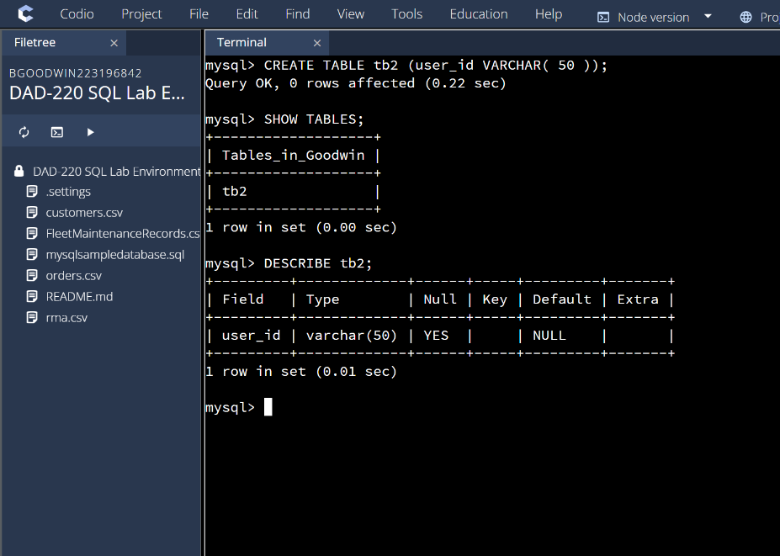
This shows me creating a table with a user that could contain 50 characters in the database of Goodwin, showing that this table was created and describing the parameters of this table.

- Add a second field into the table and describe it. Do this by entering the following commands after mysql>:

  - ALTER TABLE tb2 ADD newfield VARCHAR(25);
    - Press Enter.
  - DESCRIBE tb2;
    - Press Enter.
  - Capture a screenshot of the results of this action.

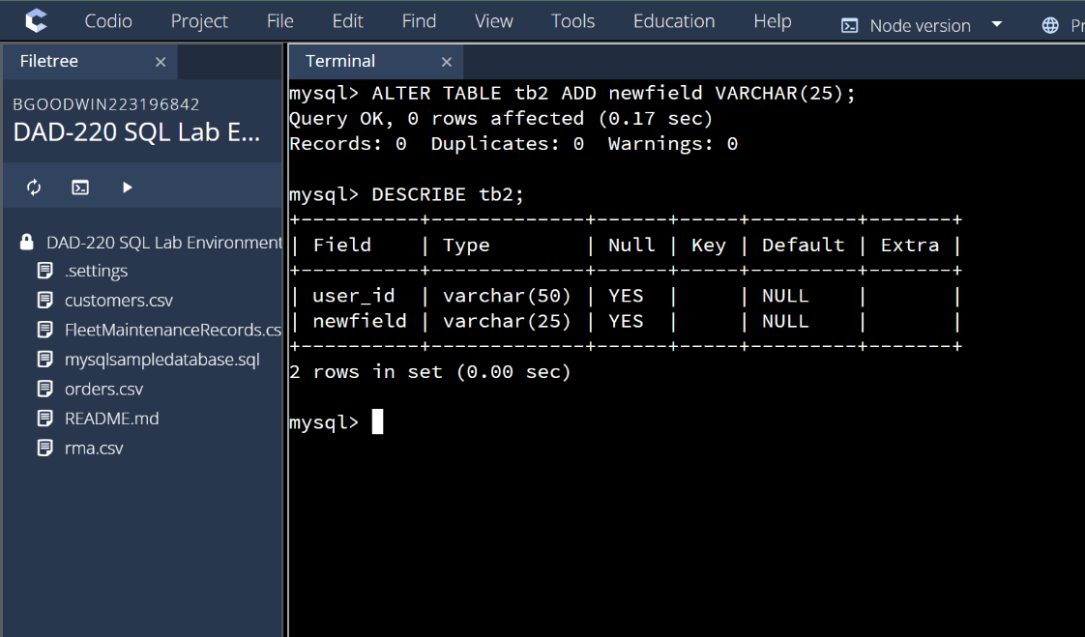

This shows me altering the table tb2 and adding a new field that can contain 25 characters in it and having the server describe what the table tb2 has in it with both fields.

- Organize your work to match the screenshot example and guidelines in the example document linked in the Supporting Materials section of the guidelines and rubric. Your submission should show that your work is original and the commands you have written for this lab worked correctly.

